Property Features of
1 Bruce St N, Thornbury
Exterior
- AIR BNB AND MOTEL ZONING.
- Prime location in Downtown Thornbury
- Exceptional Investment Opportunity
- Located on highly visible main intersection of Bruce Street & Hwy 26
- Commercial building and two short-term rentable apartments
- Steady drive-through traffic and excellent street presence
- Just steps to Thornbury's charming shops, cozy cafés, and the stunning Georgian Bay
- Short drive to private ski/golf clubs and Blue Mountain Village
- 80ft frontage on Bruce St. N and 71ft frontage on Highway 26
- Water Source: Municipal
- Sewer: Municipal
Interior
- The building features one commercial unit, currently tenanted, with a flexible layout
- Two short term rentable apartments, both currently vacant, offering excellent rental potential
Updates (2023/24)
- Fully updated
- New commercial grade roof, windows, tuck pointing, eves troughs, doors, furnaces, appliances
Commercial Unit
- 1229 Sqft (interior)
- Professional office space
- Multiple offices
- Reception area
- Staff room
- Washroom
- Spacious meeting room
Unit 1 (Upper Level)
- 1288 sqft (interior)
- 2 bed + den
- 2-bath
- Modern open-concept kitchen, living, and dining area
Unit 2 (2 Storey)
- 775 sqft (interior)
- 2-bedroom layout — ideal for a seasonal getaway or long-term tenant
- Convenient ski locker with custom hooks for skis and bikes
- Bright kitchen and airy living space
Other
- Area Influences: Beach, Dog Park, Downtown, Golf, Highway Access, Hospital, Lake/Pond, Landscaped, Library, Major Highway, Marina, Open Spaces, Park, Place of Worship, Playground Nearby, Public Parking, Quiet Area, Rec./Community Centre, Schools, Shopping Nearby, Skiing, Trails, Other

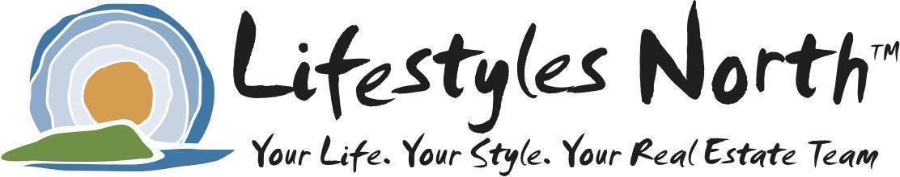
** The information provided on this Features List is provided by the owner and is believed to be accurate and reliable.
The Lifestyles North Team and Royal LePage Locations North assumes no responsibility for any errors or inaccuracies.

