Property Features of Upper Unit
1 Bruce St N, Thornbury
Exterior
- AIR BNB AND MOTEL ZONING.
- Prime location in Downtown Thornbury
- Exceptional Investment Opportunity
- Located on highly visible main intersection of Bruce Street & Hwy 26
- Steady drive-through traffic and excellent street presence
- Just steps to Thornbury's charming shops, cozy cafés, and the stunning Georgian Bay
- Short drive to private ski/golf clubs and Blue Mountain Village
- 80ft frontage on Bruce St. N and 71ft frontage on Highway 26
- Water Source: Municipal
- Sewer: Municipal
Updates (2023/24)
- Fully updated
- New commercial grade roof, windows, tuck pointing, eves troughs, doors, furnaces, appliances
Unit 1 (Upper Level) Interior

Space & Layout
- 3 Private Spaces/ Offices: Bright, versatile rooms ideal for executive suites, private treatment spaces, or client consultations.
- Expansive Open Area: Generous floor plan adaptable for workstations, collaborative lounges, or a creative showroom.
- Modern Kitchenette: Fully integrated into the main space with upgraded finishes and appliances.
- Two Bathrooms: Includes two separate washrooms (one fully equipped).

Turn-Key Finish & Condition
- Move-In Ready: Newly updated with a clean, modern aesthetic and pristine flooring throughout.
- High Exposure: Situated in a high-visibility, high-foot-traffic location in the heart of downtown Thornbury.

Ideal For
- Professional Services: Law, finance, accounting, consulting, or real estate brokerages.
- Creative Studios: Marketing, architecture, interior design, or media production.
- Health & Wellness: Multi-disciplinary clinics, aesthetics, boutique fitness, or therapy practices.

Prime Location
- Downtown Thornbury: Steps from Main Street's top dining, cafés, and local boutiques.
- Lifestyle Perks: Minutes to Georgian Bay harbourfront, private ski and golf clubs, and Blue Mountain Village.
More info:
- 1288 sqft (interior)- Please see floor plans for more detailed measurements
Other
- Area Influences: Beach, Dog Park, Downtown, Golf, Highway Access, Hospital, Lake/Pond, Landscaped, Library, Major Highway, Marina, Open Spaces, Park, Place of Worship, Playground Nearby, Public Parking, Quiet Area, Rec./Community Centre, Schools, Shopping Nearby, Skiing, Trails, Other

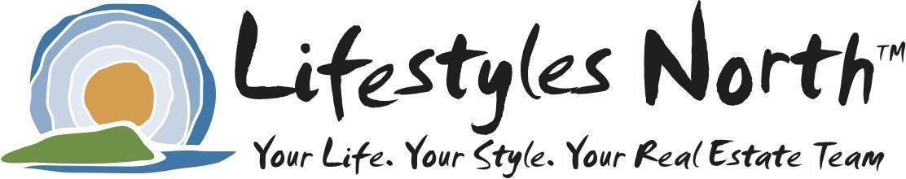
** The information provided on this Features List is provided by the owner and is believed to be accurate and reliable.
The Lifestyles North Team and Royal LePage Locations North assumes no responsibility for any errors or inaccuracies.

